7th Annual HERO RUN 5K
Sunday October 7, 2018 10:00 am
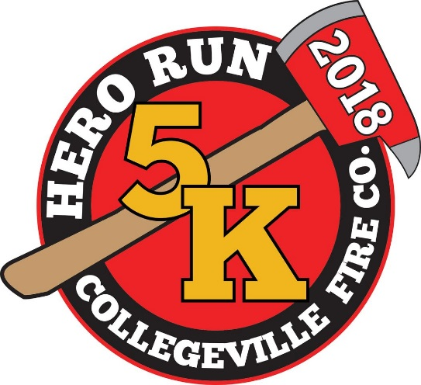
Please join the Collegeville Fire Company in a celebration of Heroes!
The 7th Annual Hero Run 5k will be held on Sunday October 7th, starting at the Collegeville Station Parking lot (3rd Ave & Chestnut St. in Collegeville Borough). Bring the kids and check out some of the vehicles and equipment that our Heroes use to keep us safe every day!
Race begins at 10:00am – packet pickup & registration 9-10am.
Register at: www.collegevillefire.org/content/herorun
Packet pick-up at Valley Forge Running Company (305 2nd Avenue, Collegeville)
Thurs. Oct 4th 10 am - 8 pm * Fri. Oct 5th 10 am - 6 pm * Sat Oct 6th 10a - 6p * At Start line Sun. Oct 7th until 10 am
First 100 to register receive a commemorative Hero Run 5k Patch & T-shirt | Medals to top finishers across age groups
***Sports Massages courtesy of Massage Envy available to runners before & after the race***
Registration Fees: $25 until Sept 7 * $30 Sept 7-Oct 6 * $35 Oct 7 (in person registration only)
Registration always $20 for current & former Military/Fire/Police/EMS
Children 12 and under always $10
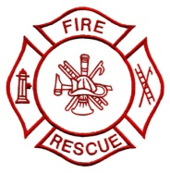
www.facebook.com/cfcherorun5k

