3rd Annual HERO RUN 5K
Sunday October 19, 2014 10:30 am
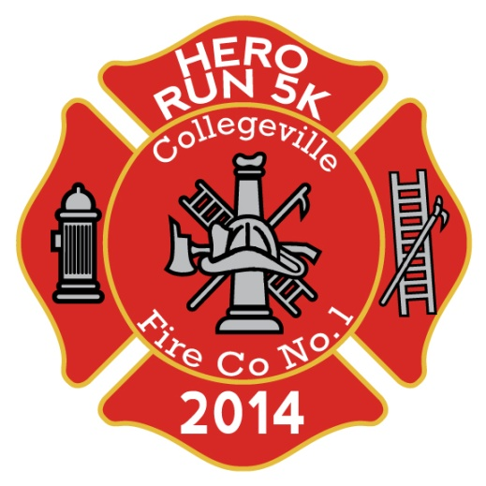
Please join the Collegeville Fire Company in a celebration of Heroes!
The 3rdAnnual Hero Run 5k will be held on Sunday October 19th, starting from the Collegeville Station Parking lot (3rd Ave & Chestnut St. in Collegeville Borough). Be sure to bring the kids and check out some of the vehicles and equipment that our Heroes use to keep us safe every day!
Race begins at 10:30am – packet pickup & registration available until 10am.
Register at: www.collegevillefire.org (click "events")
Packet pick-up at Valley Forge Running Company (305 2nd Avenue, Collegeville)
Thursday October 16th 4pm - 8pm * Friday October 17th 11am-6pm * At Start line Sunday October 19 until 10am
First 150 to register receive a commemorative Hero Run 5k Patch & Shirt | Medals to top finishers across age groups
***Free sports Massages courtesy of Massage Envy available to runners before & after the race***
Registration Fees: $25 until Sept 28 * $30 Sept 29-Oct 18 * $35 Oct 19 (in person registration only)
Registration always $20 for current & former Military/Fire/Police/EMS (must present valid ID at packet pick-up)
Children 12 and under $10
Portion of all proceeds to be donated to the “Montgomery County Hero Fund”
www.facebook.com/CFCHERORUN5k

