4th Annual HERO RUN 5K
Sunday October 18, 2015 10:30 am
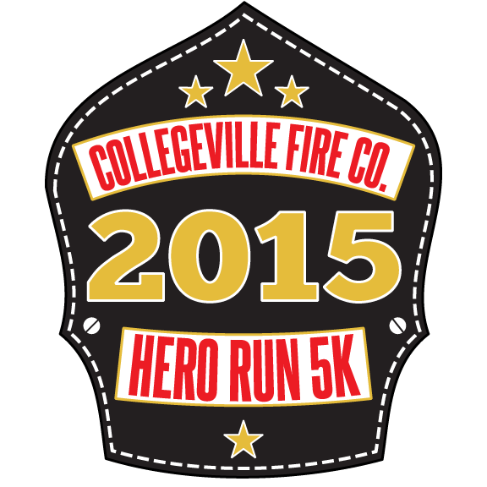
Please join the Collegeville Fire Company in a celebration of Heroes!
The 4th Annual Hero Run 5k will be held on Sunday October 18th, starting at the Collegeville Station Parking lot (3rd Ave & Chestnut St. in Collegeville Borough). Bring the kids and check out some of the vehicles and equipment that our Heroes use to keep us safe every day!
Race begins at 10:30am – packet pickup & registration 9:30-10:15am.
Register at: www.collegevillefire.org/content/herorun
Packet pick-up at Valley Forge Running Company (305 2nd Avenue, Collegeville)
Thurs. Oct. 15th 4pm - 8pm * Fri. Oct. 16th 10am-8pm * Sat Oct 17th 10a-6p * At Start line Sun. Oct 18 until 10am
First 100 to register receive a commemorative Hero Run 5k Patch & T-shirt | Medals to top finishers across age groups
***Free Sports Massages courtesy of Massage Envy available to runners before & after the race***
Registration Fees: $25 until Sept 20 * $30 Sept 20-Oct 17 * $35 Oct 18 (in person registration only)
Registration always $20 for current & former Military/Fire/Police/EMS
Children 12 and under always $10
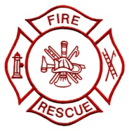
www.facebook.com/cfcherorun5k

